Use of Terrestrial Lidar to Quantify Small Mammal Habitat

Jonathan Batchelor1

1School of Environmental and Forest Sciences, University of Washington.

1. **Abstract**

The major objective of this paper was to identify correlations between forest structure, as quantified by Terrestrial Lidar Scanner (TLS), and northern flying squirrel (*Glaucomys sabrinus*) (GLSA) populations. 144 plots at 16 sites that had small mammal trapping stations established, were scanned with a TLS. Metrics for depth and openness of the stands were developed from the TLS data. Relationships between these metrics and GLSA population were explored using PCA ordinations. No correlation between forest structure and GLSA populations was detected with our methodology.

1. **Introduction**
   1. **Forest Structure**

The amount and arrangement of aboveground biomass can loosely be describe as the structure of a forest. This structure can have an immense influence on how a forest ecosystem functions and the species composition (Beier and Drennan 1997, Shugart et al. 2010). There is a cyclical relationship as the species composition of an area influences the structure of the forest and the forest structure in turn, influences the species composition. Of particular interest for this study is how the physical structure relates to the abundance of small arboreal mammals. The arrangement of the physical biota in a forest dictates the connectivity and distance between foraging areas and micro refugia for these arboreal mammal species. Similarly, the “openness” of a stand dictates how far potential predators are able to see as well as the overall canopy closure and light levels.

* 1. **Small Mammals**

Arboreal mammals are incredibly important, not only for their own fulfilling of ecological niches and roles within an ecosystem, but they also represent important food sources for many threatened apex predators such as the spotted owl (*Strix occidentalis*) (Smith et al. 1999). One arboreal mammal of particular interest is the northern flying squirrel (*Glaucomys sabrinus*) (GLSA). Flying squirrels have been the subject of much study, and elements of their ecology such as range, diet, and behavior are becoming understood (Wilson 2010). However, one element that has yet to be quantified in a satisfactory manner is how much of an influence the physical structure of a forest impacts their abundance. Is the arrangement and openness of a forested stand related to the presence of flying squirrels? The ability to answer this question is confounded by how notoriously difficult is has been to quantify forest structure.

* 1. **Lidar**

Historical measurements of forest structure have included the use of handheld densitometers and visual assessment of tree crown diameter. Such measurements are notoriously influenced by observer bias (Vales and Bunnell 1988). Over the last several years, lidar has come to be an extremely valuable tool for quantifying element of forest structure. The most common uses of lidar include deriving biomass estimates (Seidel et al. 2013), determining leaf area index (Zhao et al. 2011), creating vegetation density profiles (Ashcroft et al. 2014), and quantifying biometrics such as tree height and tree crown size (Srinivasan et al. 2015). One element that has not been as thoroughly explored is the use of lidar to quantify forest structure as it relates to habitat preference of individual species.

* 1. **Objectives**

The purpose of this study is twofold:

1. To develop a set of plot and stand-level indices from a Terrestrial Lidar Scanner (TLS) that quantifies the multidimensional arrangement and amount of forest structure from the forest floor to the upper canopy.
2. To use these indices to quantify forest structure at sites that have small mammal trapping data and to find correlations between forest structure and abundance of northern flying squirrels (Glaucomys sabrinus) (GLSA).

**3. Methods**

**3.1 Scan Acquisition**

I selected 16 forested stands within the Cascade Range that have had previous small mammal trapping done (Figure 1). The established 3x3 trapping grid consisted of 9 trap stations spaced 100m apart. There was a total of 144 plots over 16 sites. I used a Faro Focus 3D 120 Terrestrial Lidar Scanner (TLS) to perform a scan at each trapping plot, resulting in 144 scans. The scanner reliably received returns for objects ≤ 60m away. Each panoramic scan captured a horizontal window from 0 to 360 degrees and a vertical window from -60 to 90 degrees. Vertical scan lines were spaced every 0.035 degrees, resulting in a 10,266 horizontal x 4267 vertical resolution per scan. Each scan required approximately 10 minutes to complete.

**3.2 Scan Processing**

Initial scan processing consisted of filtering artifacts and noise present in the scan data using preset filters in Faro Scene version 5.3.3 (Ulrich Von Zadow 2014). Dark scan points were isolated using an intensity (return signal strength) threshold of 200. Stray or isolated scan points were removed using a grid size of 3px, distance threshold of 0.02m, and allocation threshold of 33.3%.

Scans were then exported into Leica PTX format which preserved the scanning acquisition structure with fixed angular increments between scan pulses resulting in a spherical coordinate system. PTX reader (Kimball et al. n.d.) was then used to create two-dimensional intensity rasters (Figure 2) and depth (range) rasters using first-return point values. Each column of pixels represented an individual scan line. Each pixel represented an angular location where the laser pulse was fired. Each scan resulted in 10,266 x 4,267 pixel rasters.

**3.3 Depth and Openness Metric Calculation (Site Signatures)**

Below-ground pixels were visually identified and removed in each depth raster. The number of pixels above ground in each vertical scan line in the depth raster was then divided into 100 equally spaced vertical increments (from ground to vertical) using a custom MATLAB script (Figure 3). This discretization process minimized potential effects of slope within and across plots. We then averaged both depth and percent of “no returns” (openness) for each increment across the entire 360º horizontal view. Structural signatures were created for each forest by graphing depth and openness using mean and standard deviation of the 9 plots surveyed within each stand.

**3.4 Assessment of Site Delineation**

The analytical methods used for this study were a multi-step process. For the lidar data, the first step assessed the ability of our signatures to delineate between sites by mapping plot locations in a Principle Components Analysis (PCA) ordination. The second step mapped locations of sites in a PCA ordination and checked for visible clustering of sites with higher small mammal populations. The third step determined what similarities sites with high small mammal populations had, compared to sites with low small mammal populations.

To assess the ability of our signatures to delineate between sites, PCA ordination was used. The depth metric was relativized by identifying the maximum return value for distance (53m), then identifying points within the data that had no distance value (i.e. sites that had no vegetation to reflect back a lidar pulse at a height increment [41 sites]). For the purpose of ordination, every cell required a distance value. The plots that had no distance value were given a value of 100 to represent a distance that was substantially larger than any of the actual return data. The relativized depth metric was transformed to a percentage of the distance measured compared to the maximum value of 100. Thus a value of 53m became 53%.

A mantel test was performed to determine if spatial auto correlation was present between the openness and depth values. The Pearson method was used with 999 permutations. I also evaluated how well individual plots in each stand clustered, and if they visibly differentiated from each other. Ordination was performed using all 144 plots with each plot having all depth and openness values assigned to it, resulting in a 144 x 200 main matrix. Convex polygons (i.e., convex hulls) were drawn around the points plotted for each forest.

**3.5 Association of Mammals to Sites**

To determine what sites had “low”, “moderate”, and “high” populations of small mammals, a hierarchical agglomerative clustering, expressed with a dendrogram was used to classify the small mammal data into three groups. Two methods were used (Ward D2 and Complete) to contrast results. In addition, using just the GLSA population subset of the mammal data, “low”, “moderate”, and “high” groups were determined by identifying two natural breaks.

The structural signature values for depth, variance in depth, openness, and variance in openness for all 16 sites were used for PCA ordinations. Five ordinations were preformed: Using the full set of Openness and Depth values for all plots, using just the openness values for all plots, using just the depth values for all plots, using the variance between the openness values at each plot by plotting only the sites, and using the variance between the depth values at each plot by plotting only the sites. The small mammal abundance data was included as explanatory variables. I assessed if sites that had higher small mammal populations were relatively closer to each other, compared to sites that had lower small mammal populations.

**3.6 Similarities of Sites in Relation to Mammal Population**

I plotted out the depth, the variance in depth, the openness, and the variance in openness as four separate line graphs for the “high” GLSA population sites. Using these graphs, the angular sections that were most similar were identified. This range was subset from all sites and the PCA ordinations were performed on the subset data.

1. **Results**
   1. **Site Signatures**

The site signatures were produced (Figure 4) and visually examined to assess if they graphically appeared to differentiate from each other. PCA ordination (Figure 5) showed the depth values and openness values influencing point location in perpendicular directions, indication the variables were not correlated with each other. PC1 explained 38.3% of variance, and PC2 explained 20.1% of variance. A second plotting of the same PCA was produced (Figure 6) to illustrate the relative location of sites within the ordination of the plots.

* 1. **Mantel Test**

The Mantel test was performed (Figure 7) and returned a Mantel R statistic of 0.1697 with a significance of 0.001. The null hypothesis that the two matrices have a linear correlation is rejected.

* 1. **Mammal Grouping**

The three year average from the trapping data (Table 1) was used for the hierarchical agglomerative clustering (Figure 8) but the clustering returned groups that varied widely in the number of GLSA individuals. This is not surprising as there were not consistent small mammal populations across all sites. The clustering was done to investigate the results but they were rejected for use in the study. Instead, sites were divided into high, medium, and low population groups of GLSA based on what appeared to be natural breaks in the population distribution.

* 1. **PCA**

The 5 ordinations that were produced are presented in figures 9-13. In all ordinations preformed, the hulls clustered around the center in respect to the small mammal populations measured at each site.

* 1. **Subset PCA**

The standard deviation of the depth, openness, variance in depth, and variance in openness for the sites that had the highest GLSA populations is presented in figure 14. The angular increments between 40 and 60 were where the high GLSA sites were most similar. The plot data was subset to this range and the 5 PCA ordinations were prepared again. The ordinations are presented in figures 15-19. These ordinations were similar to the ordinations that were produced using the full set of data in that the hulls clustered around the center with no visible separation between the sites that had high or low GLSA populations.

1. **Discussion**
   1. **Site Delineation**

The first objective of this paper was to develop a methodology that used TLS to quantify forest structure in a manner that effectively delineated sites with differing forest structure. We tested our methodology by preforming a PCA ordination on the data to determine if the sites that were scanned separated out. The sites within the PCA did cluster around the center so upon first examination it appeared that there was no meaningful separation of the sites. By highlighting individual sites within the ordination space, it became clearer that sites were separating out, indicating that our values were returning values for sites that did quantify forest structure in a manner that could distinguish between sites. Our mantel test also supported the claim that our depth and openness metrics were measuring different elements of the forest structure and not simply duplicating the same measurement.

* 1. **PCA ordinations**

There were a total of 10 different ordinations preformed. 5 with the full set of data and 5 with a subset of the data. The results for all ordinations were similar and did not provide evidence that the sites with higher GLSA populations were significantly different than sites that had low GLSA populations. The second objective of this paper was to use the indices derived from the TLS to find correlations between forest structure and GLSA populations. With this methodology, no correlation was detected.

* 1. **Conclusions**

The failure of this paper to detect correlations is potentially due to one of three issues. First, the sampling method that was used to collect structural data via TLS may be flawed or inappropriate for addressing questions in relationship to forest structure and species habitat. The methodology is still very much experimental and was derived thorough an exploratory study looking at the possible used for TLS in forest ecology. Future study revolving around this particular methodology is required before its utility can be assessed.

Second, our statistical methods could be inappropriate. The methods employed were partially directed to fulfill class requirements and may simply be incapable of detecting the correlations that were sought. To address this issue, a fuller understanding of potential statistical methods needs to be acquired. Studies such as this that is geared toward trying to tease out relationships need to be approached with some caution to ensure methods aren’t employed that bias results toward the expected outcome of the researcher.

Third, there may simply be no quantifiable correlation between the difference in forest structure in forests that were sampled and GLSA populations. The failure to detect a correlation may simply be because the correlation doesn’t exist. There are likely metrics that can be measured that correlate with GLSA populations but looking at above ground forest structure may not be relatable to populations.

* 1. **Next Steps**

The use of TLS in ecological applications will continue to expand and increase and is a field of exciting possibility. The methodology outlined in this paper may not be appropriate but I feel it does offer a starting point for possible future research as well and answering questions about how TLS can be employed to quantify forests in an ecological manner.

**Literature Cited**

Ashcroft, M. B., J. R. Gollan, and D. Ramp. 2014. Creating vegetation density profiles for a diverse range of ecological habitats using terrestrial laser scanning. Methods in Ecology and Evolution 5:263–272.

Beier, P., and J. E. Drennan. 1997. Forest structure and prey abundance in foraging areas of northern goshawks. Ecological Applications 7:564–571.

Kimball, J., M. J. Olsen, and K. Ponto. (n.d.). PTX READER.

Seidel, D., K. Albert, C. Ammer, L. Fehrmann, and C. Kleinn. 2013. Using terrestrial laser scanning to support biomass estimation in densely stocked young tree plantations. International Journal of Remote Sensing 34:8699–8709.

Shugart, H., S. Saatchi, and F. Hall. 2010. Importance of structure and its measurement in quantifying function of forest ecosystems. Journal of Geophysical Research: Biogeosciences 115.

Smith, R. B., M. Z. Peery, R. J. Gutiérrez, and W. S. Lahaye. 1999. The Relationship between Spotted Owl Diet and Reproductive Success in the San Bernardino Mountains, California. The Wilson Bulletin 111:22–29.

Srinivasan, S., S. C. Popescu, M. Eriksson, R. D. Sheridan, and N.-W. Ku. 2015. Terrestrial Laser Scanning as an Effective Tool to Retrieve Tree Level Height, Crown Width, and Stem Diameter. Remote Sensing 7:1877–1896.

Ulrich Von Zadow. 2014. Scene. FARO http://www.faro.com.

Vales, D. J., and F. L. Bunnell. 1988. Comparison of methods for estimating forest overstory cover. I. Observer effects. Canadian Journal of Forest Research 18:606–609.

Wilson, T. M. 2010. Limiting factors for northern flying squirrels (Glaucomys sabrinus) in the Pacific Northwest: a spatio-temporal analysis. PhD Thesis, Union Institute and University.

Zhao, F., X. Yang, M. A. Schull, M. O. Román-Colón, T. Yao, Z. Wang, Q. Zhang, D. L. Jupp, J. L. Lovell, and D. S. Culvenor. 2011. Measuring effective leaf area index, foliage profile, and stand height in New England forest stands using a full-waveform ground-based lidar. Remote Sensing of Environment 115:2954–2964.

**Tables**

Table 1. A list of the 16 sites with the number of individuals captured of the three small mammals. The GLSAF column is the designation if the site was considered to have high, medium, or low population of GLSA.

|  |  |  |  |  |
| --- | --- | --- | --- | --- |
| **SITE** | **GLSA** | **NECI** | **NEFU** | **GLSAF** |
| **East Ashland** | **26** | **6** | **0** | **H** |
| **Bull Gap** | **23** | **8** | **0** | **H** |
| **Wildcat** | **18.33333** | **1** | **0** | **H** |
| **Trail Creek** | **18** | **5** | **13** | **H** |
| **Bonanza** | **16.66667** | **2.666667** | **0.666667** | **M** |
| **Ferngully** | **16.33333** | **0** | **0** | **M** |
| **Schooner Creek** | **15** | **0.666667** | **0** | **M** |
| **Beehave** | **11.33333** | **3.33333** | **0** | **M** |
| **Chintiminy** | **11** | **0.666667** | **0** | **M** |
| **Farmer Easy** | **10** | **2.333333** | **0** | **M** |
| **Erickson Creek** | **7.666667** | **1.333333** | **0** | **L** |
| **Three Horn** | **7.666667** | **1** | **20.33333** | **L** |
| **Savage Bluffs** | **3.666667** | **3.666667** | **2.666667** | **L** |
| **Buzzard Creek** | **3.333333** | **1** | **0** | **L** |
| **Pontnu** | **3.333333** | **0** | **6.666667** | **L** |
| **Easy Tiger** | **1** | **0.5** | **0** | **L** |

**Figures**

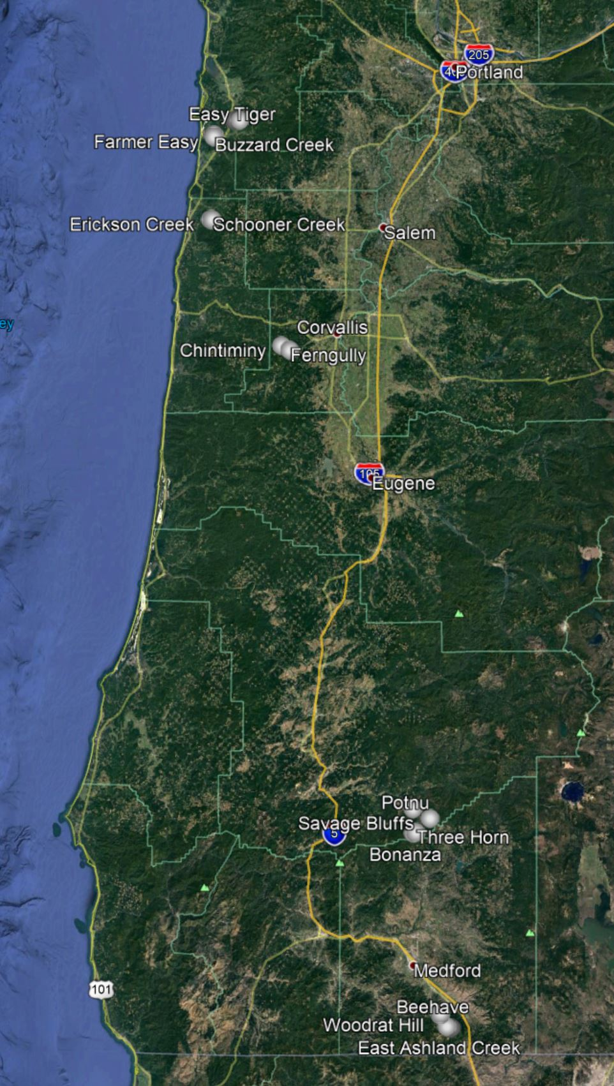

Figure 1. A map of the 16 sites used in this study. All sites were located in Western Oregon.

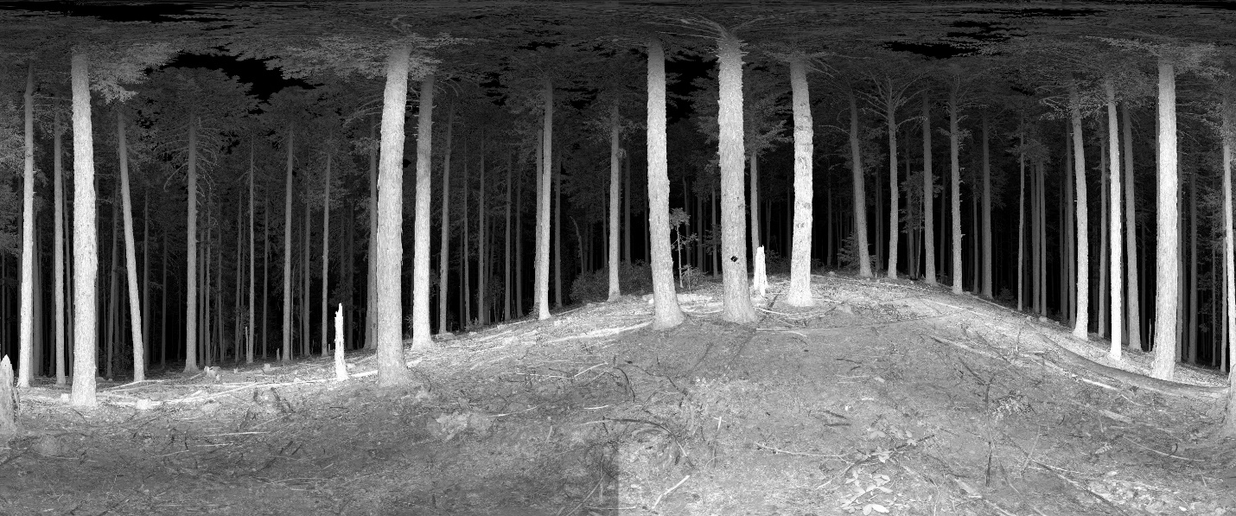

Figure 2. An example of an intensity raster derived from the TLS.

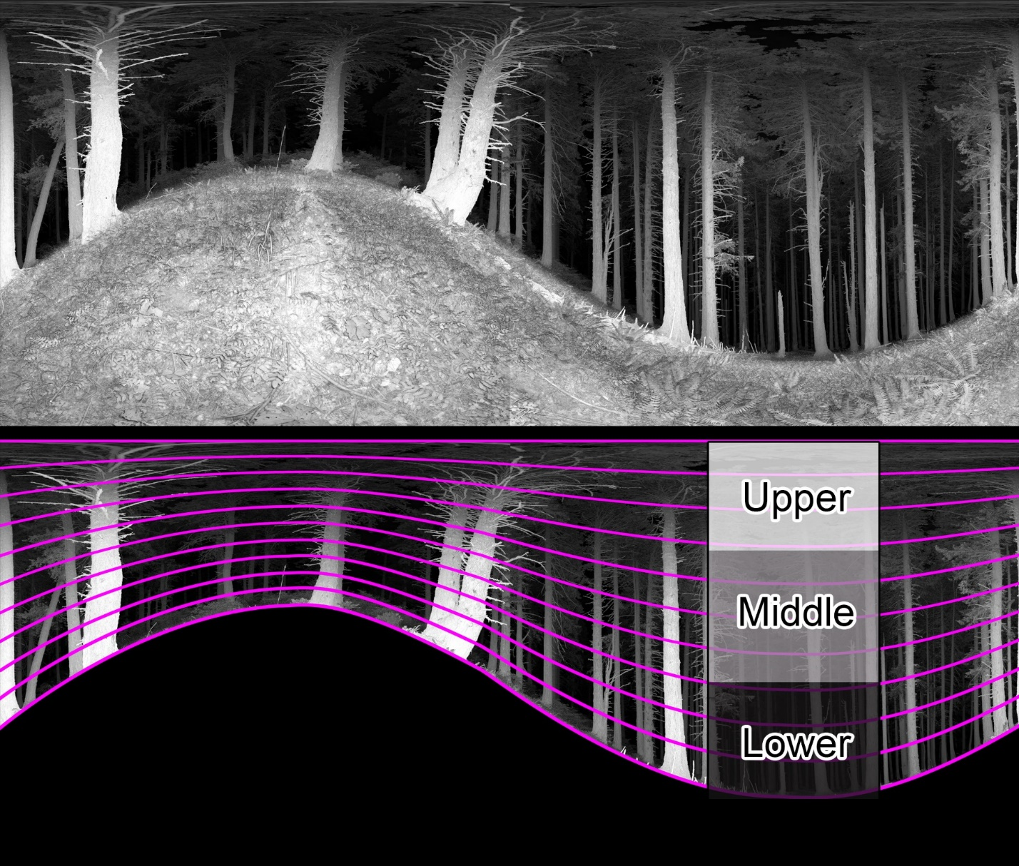

Figure 3. A conceptual figure demonstrating the process of identifying and removing the ground from a TLS scan and then segmenting the aboveground area into 100 vertical sections.

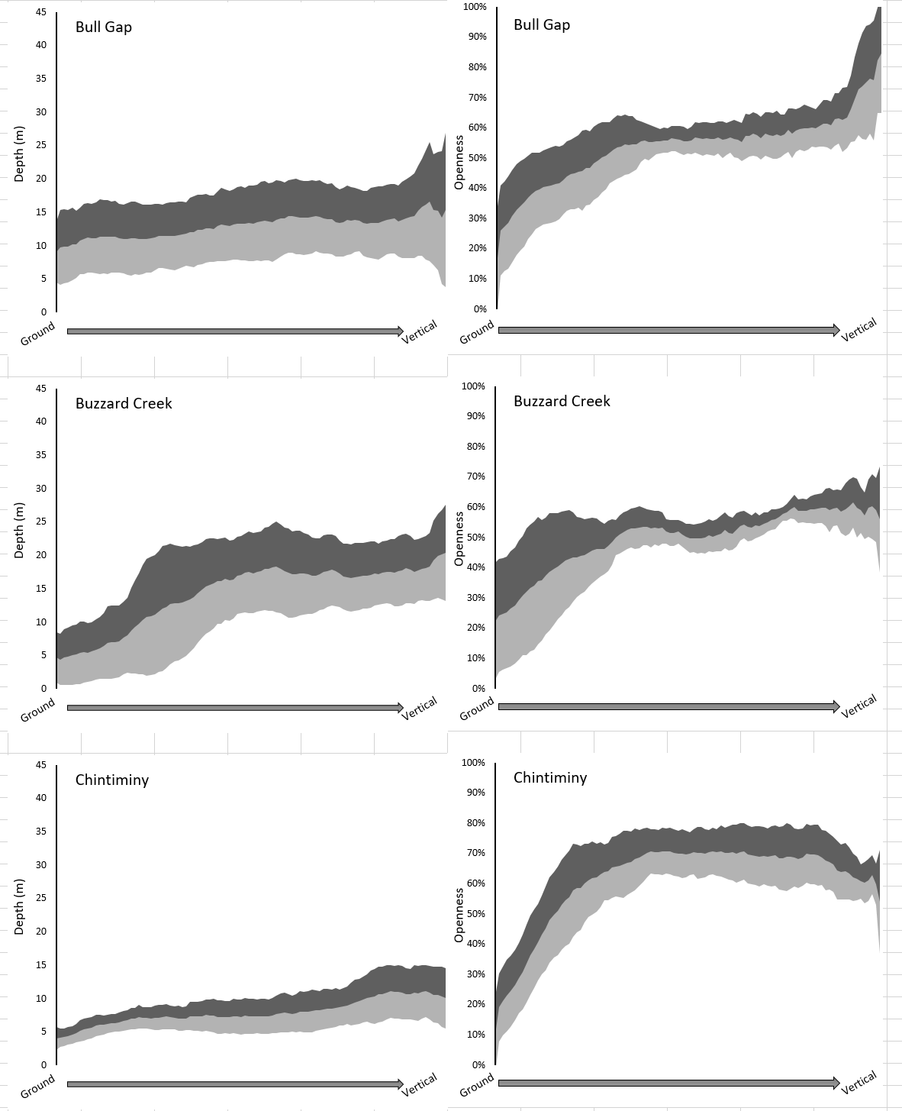

Figure 4. Site signatures from three of my 16 sites. The shaded bands represent one standard deviation above and below the mean value of the 9 plots within each site.